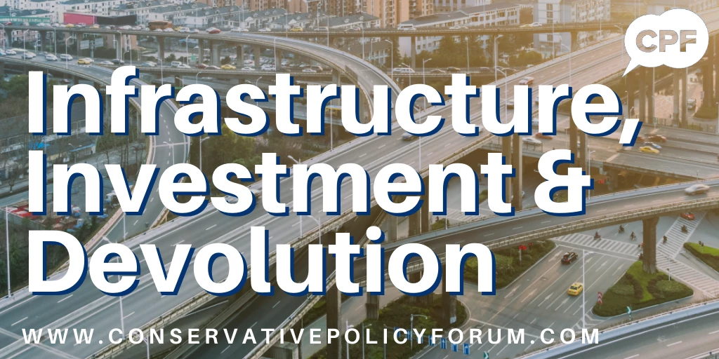

In response to the CPF discussion on Infrastructure, Investment & Devolution, we received submissions from we received submissions from 70 CPF groups, representing 75 constituencies plus one Conservatives Abroad group and at least 566 members. Since the start of the year, at least 1,900 members from 202 constituencies have participated in CPF discussions. This includes 22 groups that have newly launched and 32 that have relaunched.
Of those who participated in this consultation, 6.2% were not Party members. About one-in-eighteen (5.3%) live in swing seats (constituencies that we won or lost in the 2019 general election), almost one-in-twelve (8.0%) opposition-held seats and six-in-seven (86.7%) Conservative-held seats. About one-in-three (35%) live in London and the South East, one-in-five (19%) in the South West, one-in-five (18%) in the Midlands, one-in-eight (13%) in the North or Yorkshire & Humber, and one-in-eight (13%) in the East.
Thank you to everybody who has been involved: your suggestions are continuing to help shape our Party’s policies and our country's future.
What follows is an overview of the key points raised by CPF groups plus a few representative quotations.
“The UK has the highest ratio of debt to GDP in the G7, so restoring the economy (& treating all the other ailments that are killing people through lack of treatment) must be prioritised.”
“Education must be a priority. Lockdown significantly impacted school-age pupils, particularly those for whom home-schooling was not effective or could not be delivered adequately.”
“Think long-term.”
“The key to levelling up is an overhaul of the education system, access to affordable homes, and allowing people to run businesses without unnecessary restrictions.”
“There is too much emphasis on measuring inputs, with little or no regard to quality of output.”
“Continued blackspots in broadband and mobile coverage, particularly away from large urban areas, leaves opportunity unfairly distributed geographically.”

“Mass cycling will not replace fast broadband or even old-fashioned commuting by rail, road, water, air or tram.”
“There are too many layers of Government involved in planning: Parish/Town Councils, District Councils, Country Councils and National Government.”
“The single greatest factor in housing supply is the availability of land.”
“It’s not necessarily about devolving more powers, it’s about giving clarity on exactly who and what departments of government are responsible for what and who exactly is accountable.”
“The NHS is in urgent need of decentralisation to enable greater input from local areas, as in Germany.”
“Quangos and Public bodies collectively spend £206 billion a year: there should be significant scope to reduce these outgoings without seriously detracting from the services delivered.”
Three-in-five CPF groups (62%) emphasised the need to invest in high-speed broadband.
Two-in-five (41%) insisted that HS2 should be scrapped; if it must proceed, they suggested that construction should start from the northern end. One-in-six (17%) said East-West connections should be the priority.
Over a third (35%) called for more investment in the North.
One third (34%) called for investment in hydrogen fuel for vehicles.
One quarter (25%) believe we should build small modular nuclear reactors for power generation.
One quarter (25%) called for a national, or at least regional, water distribution network, with more reservoirs and inter-regional transfers; and an update to our sewage system.
One quarter (25%) called for more investment in apprenticeships and retraining.
One-in-nine (11%) called for more affordable housing and one-in-nine (11%) also highlighted the benefits of using prefabricated housing.
Opinions on unitary authorities were mixed, with support vs opposition split 5-4.

